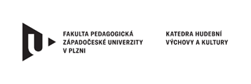
III. International Conference
CZECH REPUBLIC AND THE LUSOPHONIC COUNTRIES:
EDUCATION, ART, DIGITAL TECHNOLOGY IN TEACHING
5th - 6th October 2026

Department of Music and Culture, Faculty of Education, University of West Bohemia in Pilsen

APPLICATION

Last Name/Surname
Name
Titles
E-mail
Institution
Address
Form of Attendance
Personal / Online

PRESENTATION & PUBLICATION
All contributions intended for publication in a conference e-proceedings must be submitted in Word format, using Times New Roman font, size 12, max. length between 12 pages. They must include an abstract, keywords, the text of the contribution itself, professional literature, and the author's CV (max. 6 lines).
Application must be sent in electronic form to conferen@khk.zcu.cz by 31. 8. 2026.
If you have any questions or requests regarding presentations and publications, please contact conferen@khk.zcu.cz

Area of Presentation Education / Art / Technology in Education/ Combination
Title of Presentation
Abstract
Key words

